Program 2: Calories Burnt Program Report

# Calories burnt program flow chart

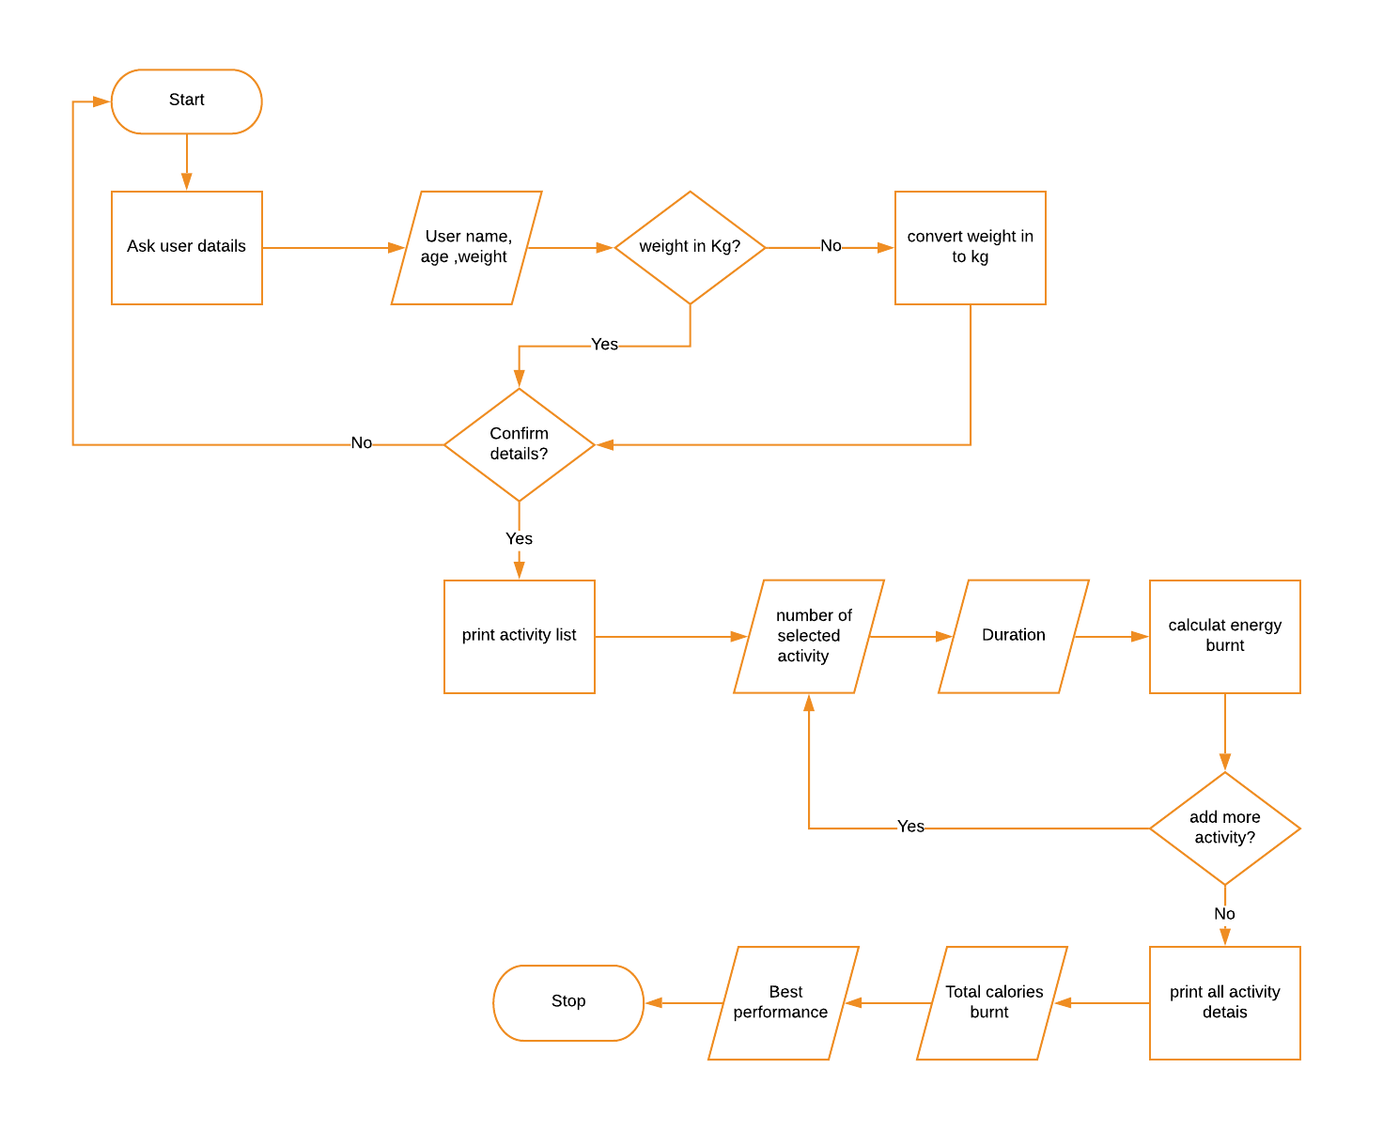

# Testing Table- Program 2: Calories Burnt Program

|  |  |  |  |  |  |  |
| --- | --- | --- | --- | --- | --- | --- |
| Test No. | Item to test | Test description | Test input | Expected result | Actual result | Comment |
| 1 | input("Please enter your name: ") | Typical valid data | Jay | Value accepted | Value accepted-program continue as normal | - |
| 2 | input("Please enter your name: ") | Extreme valid data | pppppppppppppppppp | Value accepted | Value accepted-program continue as normal | - |
| 3 | input("Please enter your name: ") | Invalid data | 10 | Error massage: re-enter value | Value accepted-program continue as normal | Allow only letter to be inputted |
| 4 | input("Please enter your name: ") | Invalid extreme data | -810 | Error massage: re-enter value | Value accepted-program continue as normal | Allow only letter to be inputted |
| 5 | input("Please enter your name: ") | Erroneous data | $%^&(() | Error massage: re-enter value | Value accepted-program continue as normal | Allow only letter to be inputted |
| 6 | input("Please enter your name: ") | Erroneous data | “HELP” | Error massage: | Value accepted-program continue as normal | Allow only letter to be inputted |
| 7 | input("Please enter your age: ") | Typical valid data | 18 | Value accepted | Value accepted-program continue as normal | - |
| 8 | input("Please enter your age: ") | Extreme valid data | 200 | Error massage: re-enter value | Value accepted-program continue as normal | Set the limit of the input number |
| 9 | input("Please enter your age: ") | Invalid data | -18 | Error massage: re-enter value | Value accepted-program continue as normal | Set the limit of the input number |
| 10 | input("Please enter your age: ") | Invalid extreme data | -200 | Error massage: re-enter value | Value accepted-program continue as normal | Set the limit of the input number |
| 11 | input("Please enter your age: ") | Erroneous data | Hi | Error massage: re-enter value | Value accepted-program continue as normal | Allow only number to be inputted |
| 12 | input("Please enter your age: ") | Erroneous data | Honorificabilitudinitatibus!! | Error massage: re-enter value | Value accepted-program continue as normal | Allow only number to be inputted |
| 13 | int(input("Please enter your weight: ")) | Typical valid data | 60 | Value accepted | Value accepted-program continue as normal | - |
| 14 | int(input("Please enter your weight: ")) | Extreme valid data | 20000 | Error massage: re-enter value | Value accepted-program continue as normal | Limit the range of inputted number |
| 15 | int(input("Please enter your weight: ")) | Invalid data | -60 | Error massage: re-enter value | Value accepted-program continue as normal | Limit the range of inputted number |
| 16 | int(input("Please enter your weight: ")) | Invalid extreme data | -20000 | Error massage: re-enter value | Value accepted-program continue as normal | Limit the range of inputted number |
| 17 | int(input("Please enter your weight: ")) | Erroneous data | Hi | Error massage: re-enter value | Error massage – user re-enter value | - |
| 18 | int(input("Please enter your weight: ")) | Erroneous data | Honorificabilitudinitatibus!! | Error massage: re-enter value | Error massage – user re-enter value | - |
| 19 | input("Please choose unite of your weight you entered (P=pound/KG): ") | Typical valid data | P | Value accepted | Value accepted-program continue as normal | - |
| 20 | input("Please choose unite of your weight you entered (P=pound/KG): ") | Extreme valid data | p | Value accepted | Value accepted-program continue as normal | - |
| 21 | input("Please choose unite of your weight you entered (P=pound/KG): ") | Invalid data | r | Error massage: re-enter value | Error massage – program let user re-enter the value | - |
| 22 | input("Please choose unite of your weight you entered (P=pound/KG): ") | Invalid extreme data | rrrrrrr | Error massage: re-enter value | Error massage – program let user re-enter the value | - |
| 23 | input("Please choose unite of your weight you entered (P=pound/KG): ") | Erroneous data | 852 | Error massage: re-enter value | Error massage – program let user re-enter the value | - |
| 24 | input("Please choose unite of your weight you entered (P=pound/KG): ") | Erroneous data | $%^&* | Error massage: re-enter value | Error massage – program let user re-enter the value | - |
| 25 | input("Confirm your information (Y/N)") | Typical valid data | Y | Value accepted | Value accepted-program continue as normal | - |
| 26 | input("Confirm your information (Y/N)") | Extreme valid data | y | Value accepted | Value accepted-program continue as normal | - |
| 27 | input("Confirm your information (Y/N)") | Invalid data | t | Error massage: re-enter value | No error massages. Program respond like “N” is inputted | Error massage – program let user re-enter the value |
| 28 | input("Confirm your information (Y/N)") | Invalid extreme data | tttttttttttt | Error massage: re-enter value | No error massages. Program respond like “N” is inputted | Error massage – program let user re-enter the value |
| 29 | input("Confirm your information (Y/N)") | Erroneous data | 32 | Error massage: re-enter value | No error massages. Program respond like “N” is inputted | Error massage – program let user re-enter the value |
| 30 | input("Confirm your information (Y/N)") | Erroneous data | @#$%^ | Error massage: re-enter value | No error massages. Program respond like “N” is inputted | Error massage – program let user re-enter the value |
| 31 | open ("mettable.txt") | File is renamed |  | Error massage,  open back-up file | Error massage – program continues without data in file | Create same file using same name as a back-up file but store in different places |
| 32 | open ("mettable.txt") | File is moved |  | Error massage,  open back-up file | Error massage – program continues without data in file | Create same file using same name as a back-up file but store in different places |
| 33 | open ("mettable.txt") | File is deleted |  | Error massage,  open back-up file | Error massage – program continues without data in file | Create same file using same name as a back-up file but store in different places |
| 34 | open ("mettable.txt") | File doesn’t exit |  | Error massage,  open back-up file | Error massage – program continues without data in file | Create same file using same name as a back-up file but store in different places |
| 35 | int(input("Please select your activity by input number located in front of met and activity name: ")) | Typical valid data | 1 | Value accepted | Value accepted-program continue as normal | - |
| 36 | int(input("Please select your activity by input number located in front of met and activity name: ")) | Extreme valid data | 100 | Error massage: re-enter value | Error massage – program let user re-enter the value | - |
| 37 | int(input("Please select your activity by input number located in front of met and activity name: ")) | Invalid data | -1 | Error massage: re-enter value | Error massage - program let user re-enter the value | - |
| 38 | int(input("Please select your activity by input number located in front of met and activity name: ")) | Invalid extreme data | -100000 | Error massage: re-enter value | Error massage – program let user re-enter the value | - |
| 39 | int(input("Please select your activity by input number located in front of met and activity name: ")) | Erroneous data | h | Error massage: re-enter value | Error massage - program let user re-enter the value | - |
| 40 | int(input("Please select your activity by input number located in front of met and activity name: ")) | Erroneous data | #$%^& | Error massage: re-enter value | Error massage – program let user re-enter the value | - |
| 41 | int(input("How long you do the activity(in minute): ")) | Typical valid data | 45 | Value accepted | Value accepted-program continue as normal | - |
| 42 | int(input("How long you do the activity(in minute): ")) | Extreme valid data | 1000000 | Error massage: re-enter value | Value accepted-program continue as normal | Limit range of number |
| 43 | int(input("How long you do the activity(in minute): ")) | Invalid data | -45 | Error massage: re-enter value | Value accepted-program continue as normal | Limit range of number |
| 44 | int(input("How long you do the activity(in minute): ")) | Invalid extreme data | -78924 | Error massage: re-enter value | Value accepted-program continue as normal | Limit range of number |
| 45 | int(input("How long you do the activity(in minute): ")) | Erroneous data | Float(100.00) | Error massage: re-enter value | Error massage - program let user re-enter the value | - |
| 46 | int(input("How long you do the activity(in minute): ")) | Erroneous data | #$%^&*( | Error massage: re-enter value | Error massage – program let user re-enter the value | - |
| 47 | input("Do you want to add more activities(Y/N): ") | Typical valid data | Y | Value accepted | Value accepted-program continue as normal | - |
| 48 | input("Do you want to add more activities(Y/N): ") | Extreme valid data | n | Value accepted | Value accepted-program continue as normal | - |
| 49 | input("Do you want to add more activities(Y/N): ") | Invalid data | Pp | Error massage: re-enter value | Error massage – program doesn’t let user to re-enter correct value but continue as “N” is inputted | Let user re-enter correct value |
| 50 | input("Do you want to add more activities(Y/N): ") | Invalid extreme data | Rtyuiknbvcdrftyuio | Error massage: re-enter value | Error massage – program doesn’t let user to re-enter correct value but continue as “N” is inputted | Let user re-enter correct value |
| 51 | input("Do you want to add more activities(Y/N): ") | Erroneous data | @#$%^&* | Error massage: re-enter value | Error massage – program doesn’t let user to re-enter correct value but continue as “N” is inputted | Let user re-enter correct value |
| 52 | input("Do you want to add more activities(Y/N): ") | Erroneous data | Print(“Hello”) | Error massage: re-enter value | Error massage – program doesn’t let user to re-enter correct value but continue as “N” is inputted | Let user re-enter correct value |

Screen shot

Start the program

Ask user details

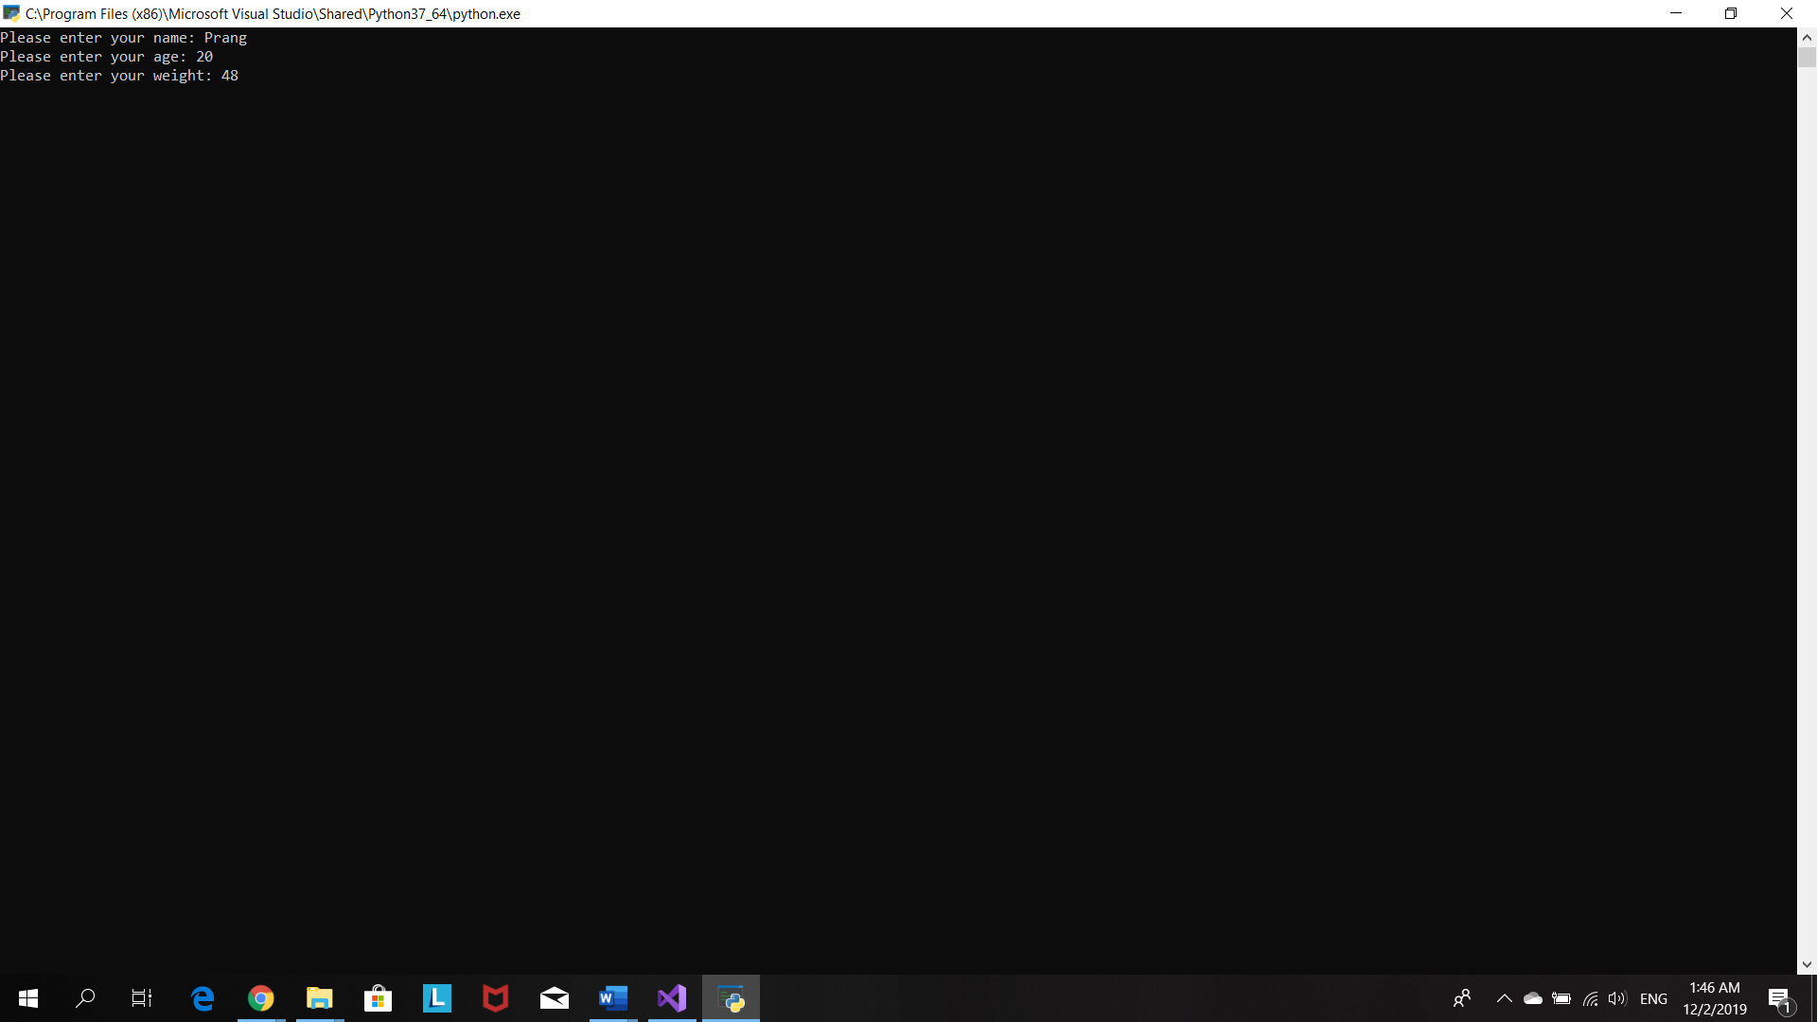

User chooses weight unit

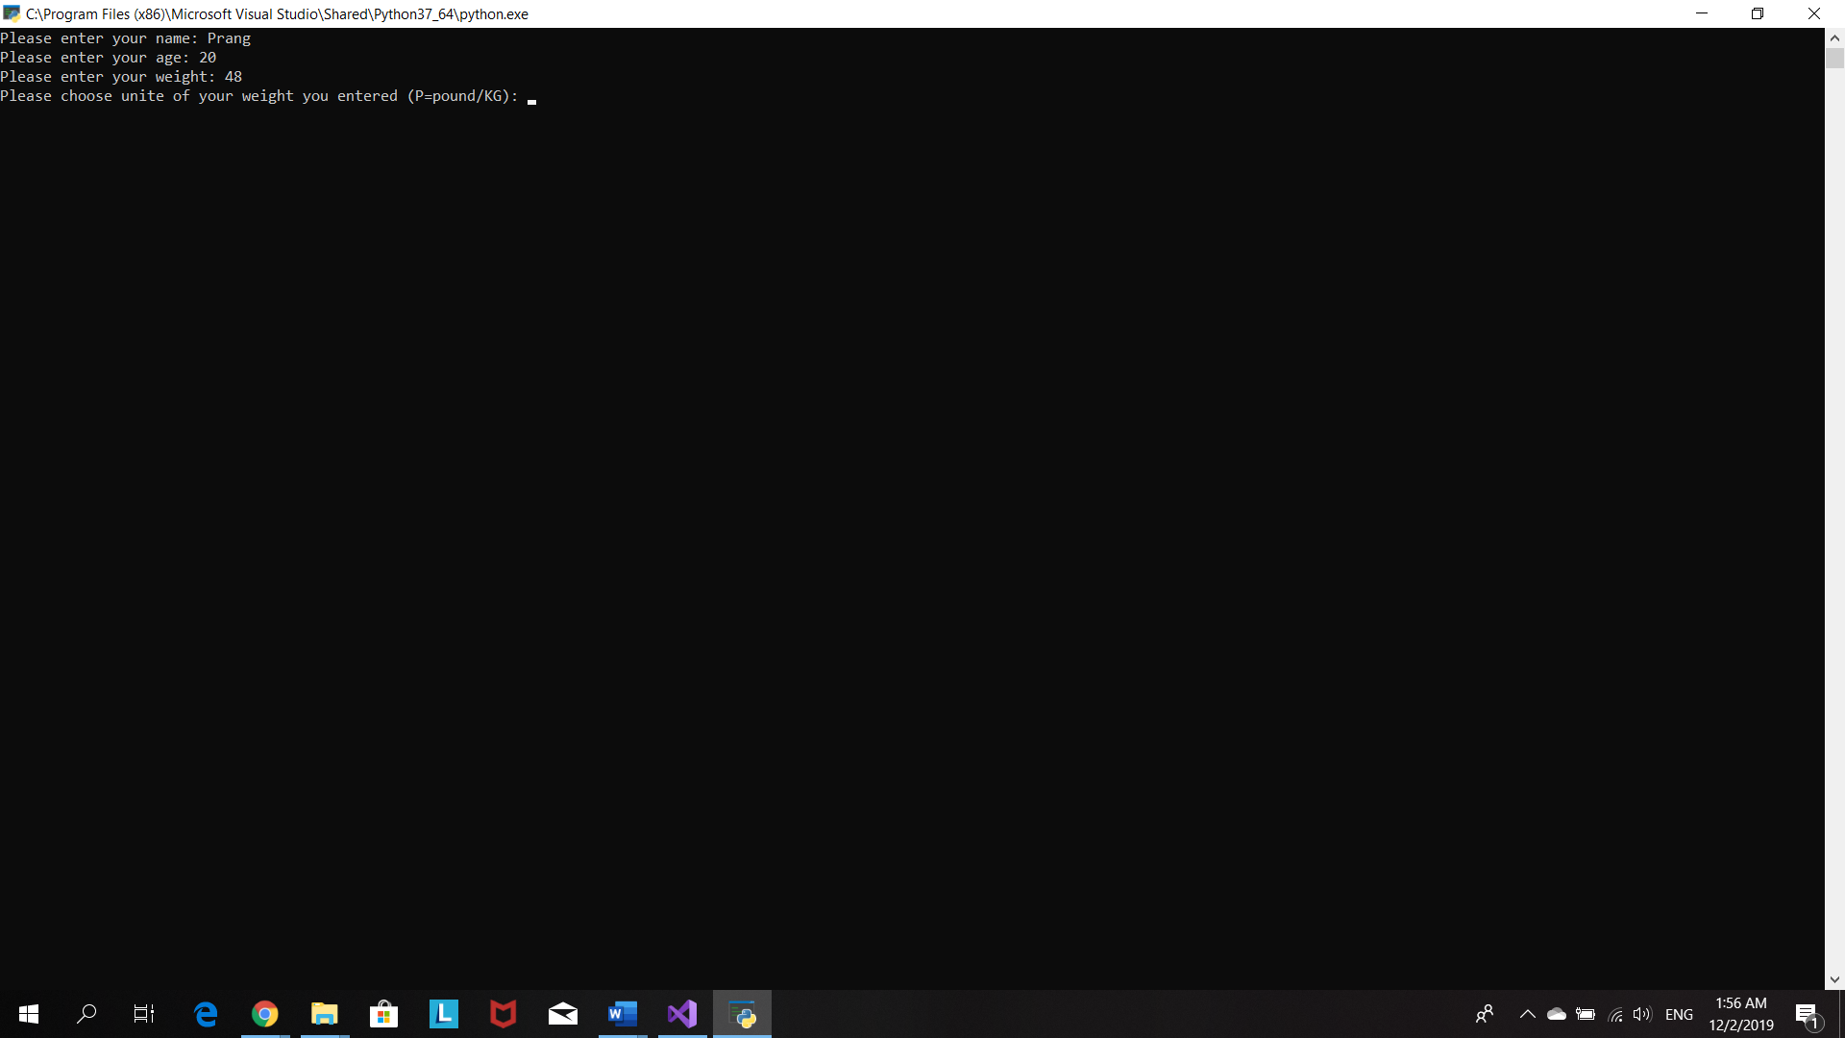

If user chooses ‘p’ for pound program will convert the input weight in to kg .

Then program will then print out the user details and ask user to confirm them.

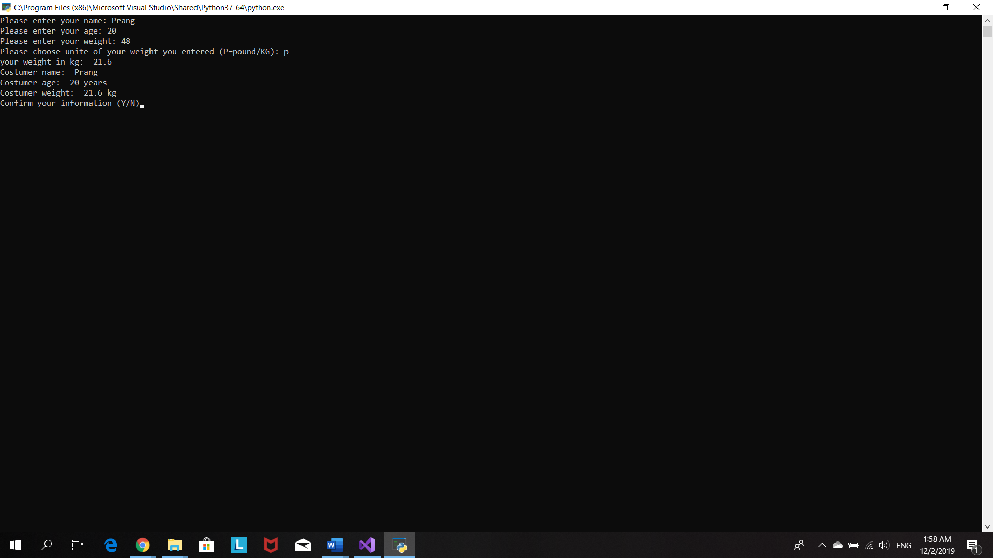

If user what to make a change in their details. He/she has to select ‘n’ for no and program will ask user to input their details again.

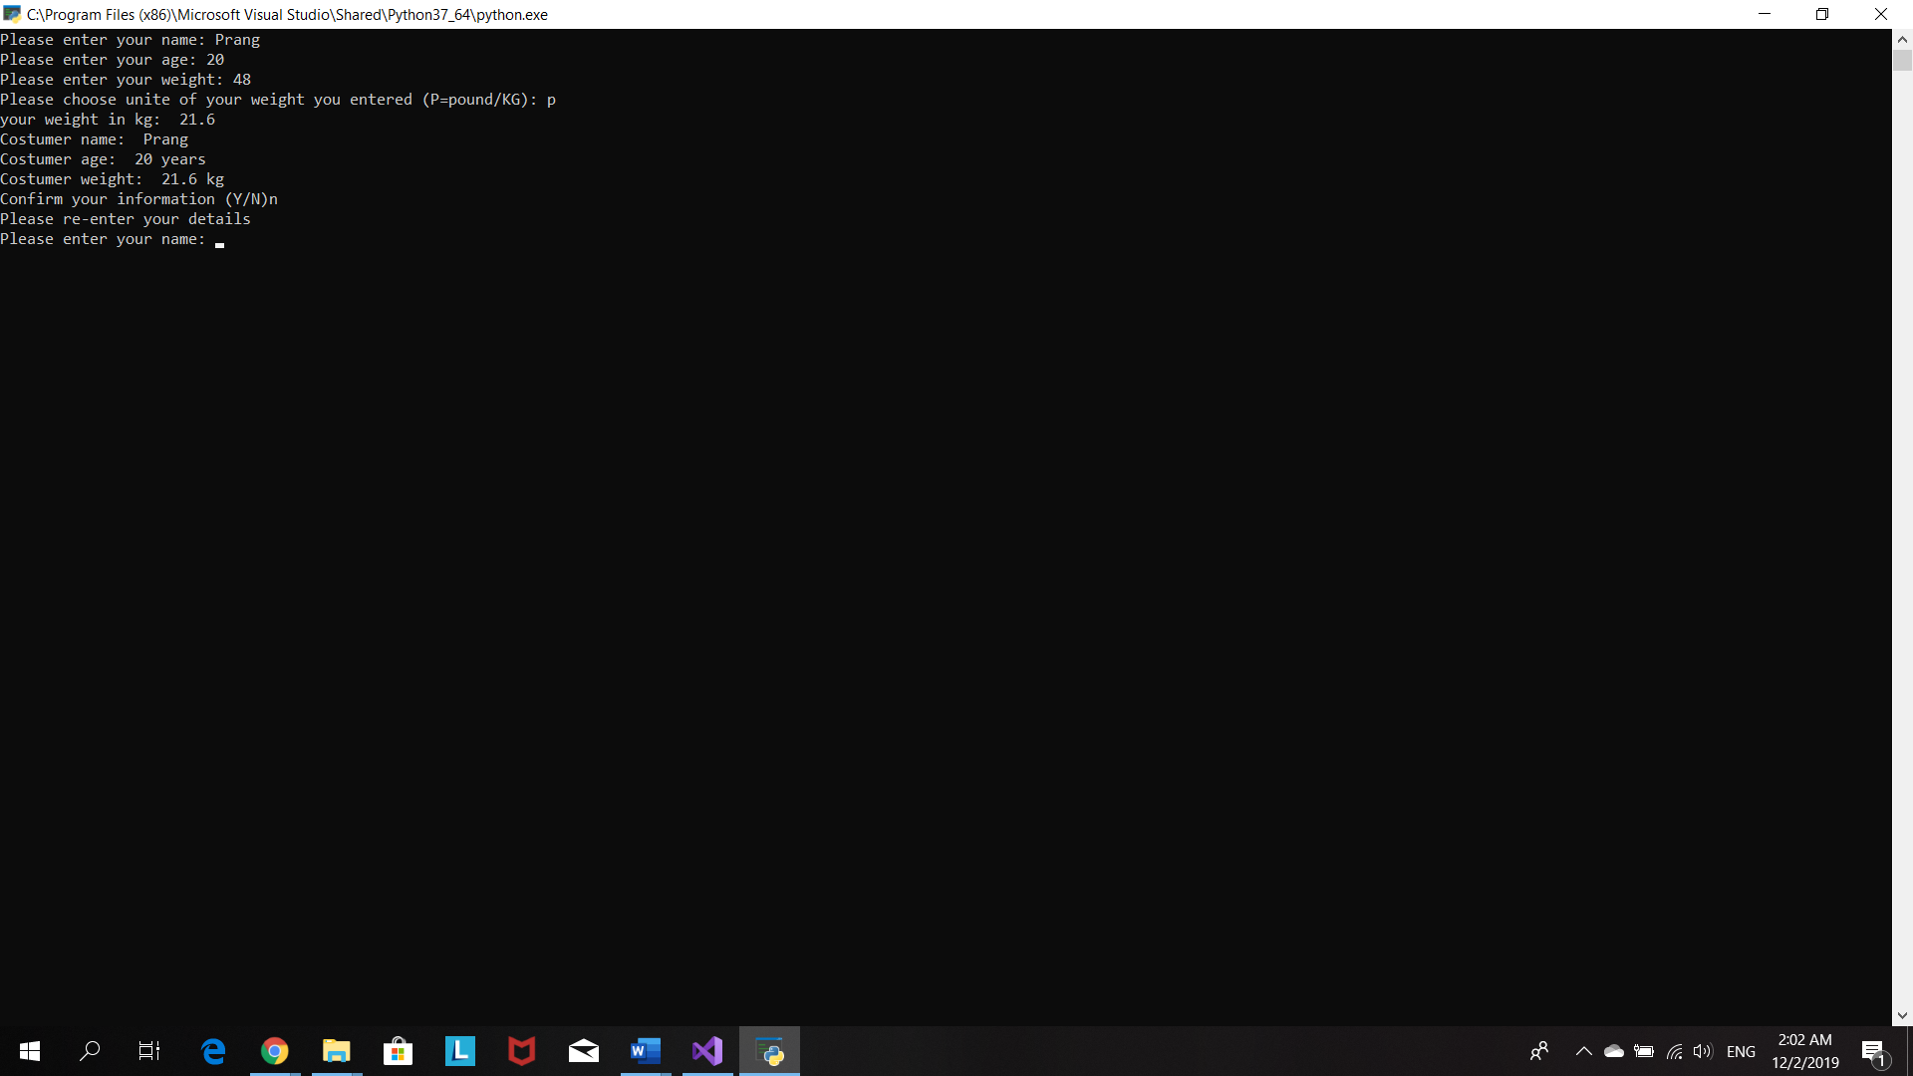

After user confirm his/her personal details, program will print out the activities list

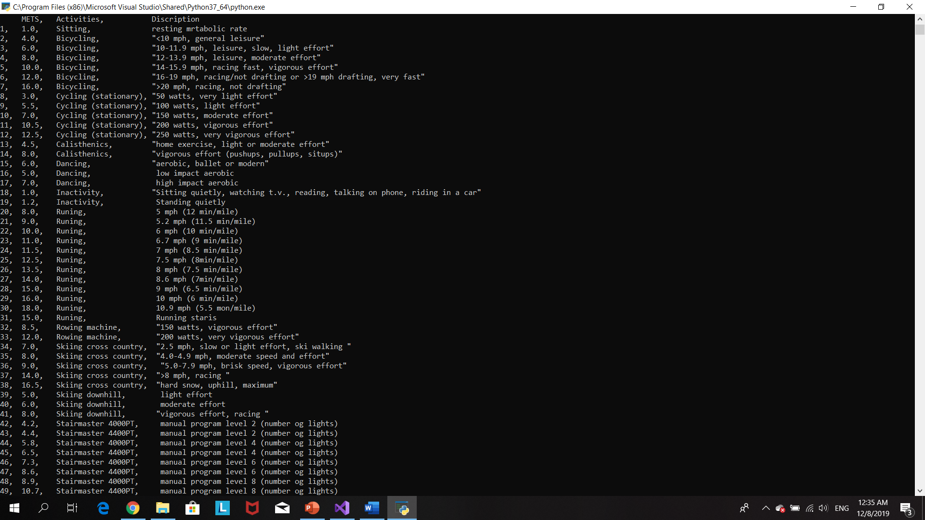

Program ask user to input number indicate activity he/she wants to choose and duration of that activity

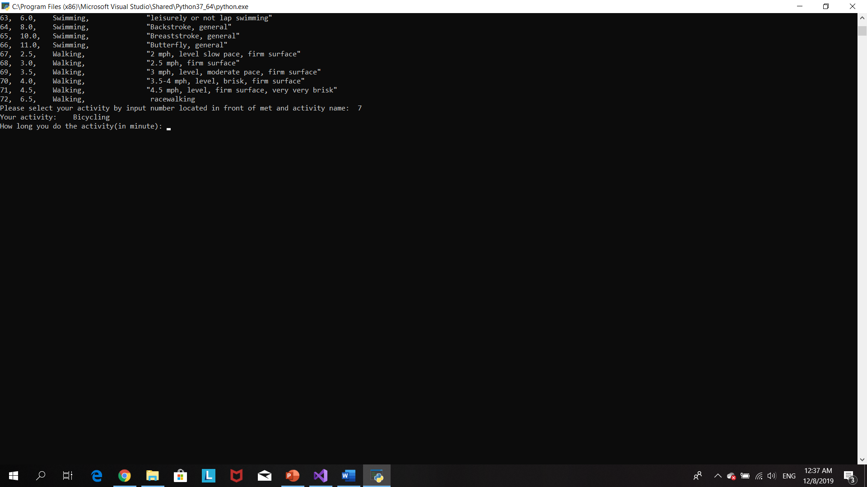

Program will calculate the calories burn of the user by doing that activity and ask user whether user want to input more activity or not.

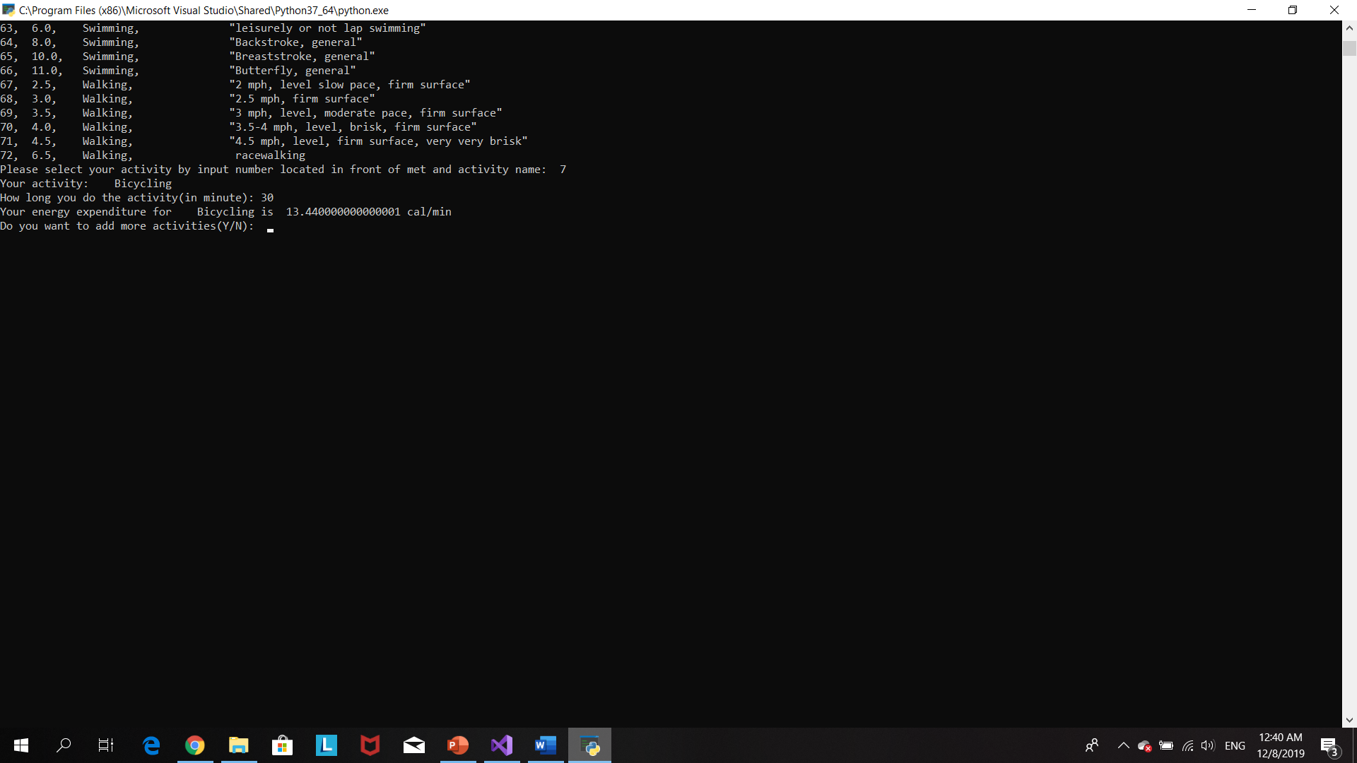

User input more activity

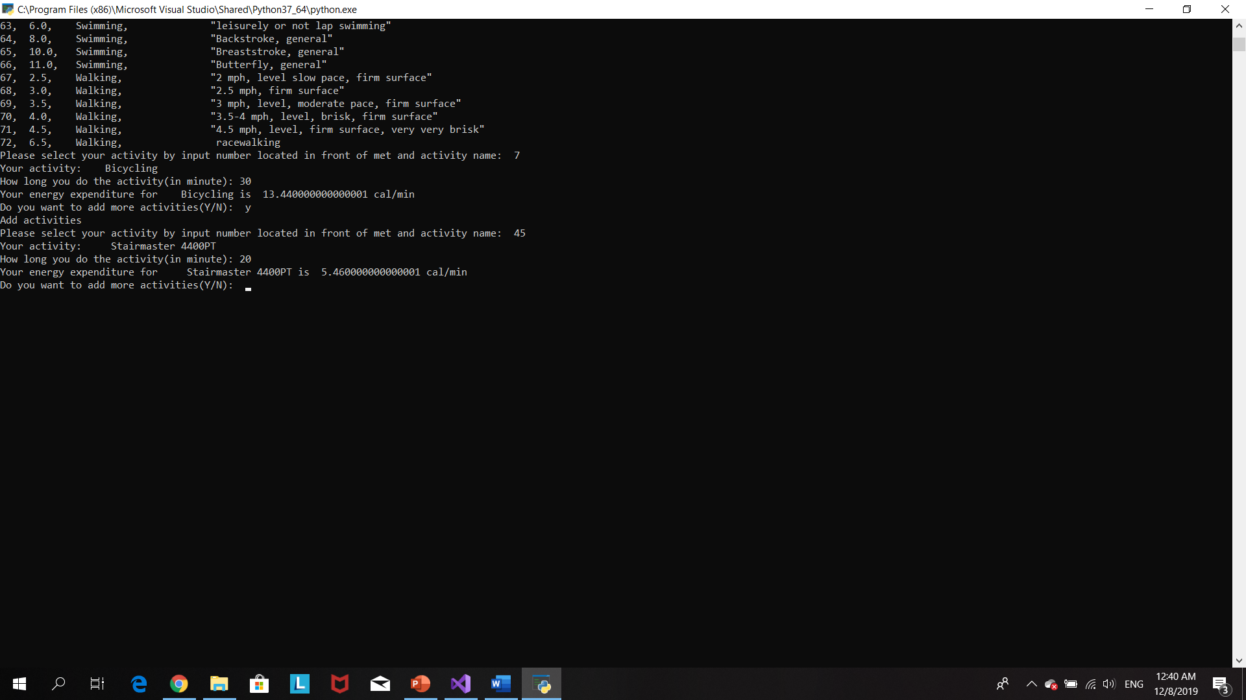

User’s record are printed out. The record including total calories burnt and best performance .

Program stops

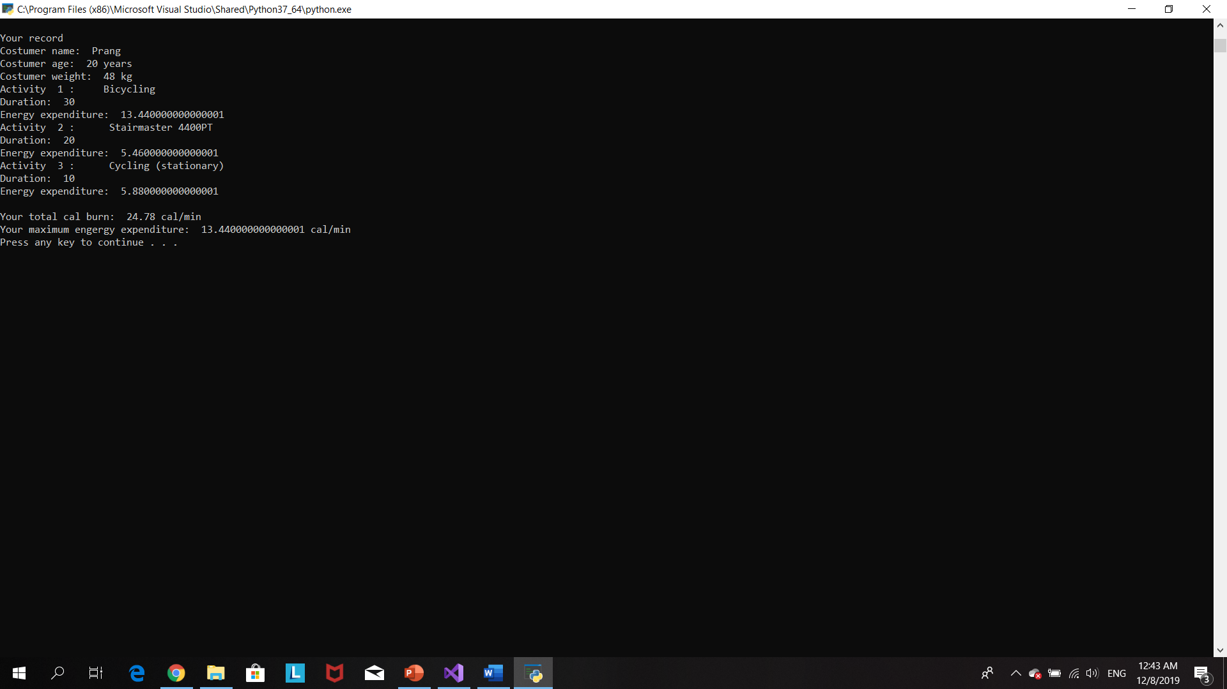

# Source code

#The purpose of this profram is to create fitness app used to record the number of calories burned during different kinds of exercise.

#Author: Prang Kongthongluck

#Version: 2.0

#Date: 06/12/2019

age=()

weight=()

mets=()

activities=[]

energy=()

energylist=[]

durationlist=[]

def user():

global weight

global name

global age

#The porpuse of this loop is to allow user to confirm their datails

while True:

name=input("Please enter your name: ")

#make user naem start with alphabet

name=name.capitalize()

age=input("Please enter your age: ")

#make sure user input interger

while True:

try:

weight=int(input("Please enter your weight: "))

break

except ValueError:

print("Please input weight as integer")

#purpose of this loop is to make sure user input collect input to weightUnit

while True:

weightUnit=input("Please choose unite of your weight you entered (P=pound/KG): ")

weightUnit= weightUnit.upper()

#convert weight from pounds in kg when user input weight in pounds)

if (weightUnit=="P"):

weight=weight*0.45

print("your weight in kg: ",weight)

break

elif (weightUnit=="KG"):

break

else:

print("Invalid input.PLease try again")

print ("Costumer name: ",name)

print("Costumer age: ",age,"years")

print ("Costumer weight: ",weight,"kg")

confirmDetails=input("Confirm your information (Y/N)")

confirmDetails=confirmDetails.upper()

if confirmDetails=="Y":

print("your informations are confirmed")

break

elif confirmDetails=="N":

print("Please re-enter your details")

user()

def MET():

global selected

global act

global energy

global duration

try:

file= open ("mettable.txt")

except:

print("Something went wrong when writing to the file")

#use file to print out list of acttivites

print(file.read())

file.close()

anothergo="Y"

#the purpose of this loop is to allow user to add more avtivity

while (anothergo=="Y"):

check="Y"

#check whether costumer enter right number for activity

while check=="Y":

#make sure user input interger

while True:

try:

userselect=int(input("Please select your activity by input number located in front of met and activity name: "))

break

except ValueError:

print ("Please input with integer")

#split each column in file

with open("mettable.txt") as file:

for i in file:

column=i.split(",")

selected=column[0]

met=column[1]

act=column[2]

if str(userselect)==selected:

print("Your activity:",act)

activities.append(act)

#make sure user input interger

while True:

try:

duration=int(input("How long you do the activity(in minute): "))

break

except ValueError:

print ("Please input with integer")

durationlist.append(duration)

#Energy expenditure calculation

energy=float(0.0175*(float(met))* weight)

#add energy in to energy list to help calculate total energ at the end

energylist.append(energy)

print("Your energy expenditure for",act,"is ",energy,"cal/min")

if (userselect <0) or (userselect>72):

print("Incorrect input, please try again")

elif (userselect >0) or (userselect<=72):

break

else:

print("Incorrect input, please try again")

anothergo=input("Do you want to add more activities(Y/N): ")

anothergo=anothergo.upper()

if (anothergo=="Y"):

print("Add activities")

elif (anothergo=="N"):

break

else:

print("Invalid input. Please try again")

MET()

#this function will help print out activity summary

def activity(a,b,c):

x=0

num=1

for i in range(len(activities)):

print("Activity ",num,": ",a[x])

print("Duration: ",b[x])

print("Energy expenditure: ",c[x])

x +=1

num +=1

def summary():

print("")

print("")

print("Your record")

print ("Costumer name: ",name)

print("Costumer age: ",age,"years")

print ("Costumer weight: ",weight,"kg")

#call function activity

activity(activities,durationlist,energylist)

totalcal=sum(energylist)

print("")

print("Your total cal burn: ",totalcal,"cal/min")

#max() print out the maximum value in the list

print("Your maximum engergy expenditure: ",max(energylist),"cal/min")

summary()

# Reference

101Computing (2017). *Python Tutorial - Takeaway Ordering System*. Available at: https://www.youtube.com/watch?v=IW_IASFhmtA

Fincher, J. (2018). *Reading and Writing CSV Files in Python – Real Python*. [online] Realpython.com. Available at: https://realpython.com/python-csv/

GeeksforGeeks. (2017). *Working with csv files in Python - GeeksforGeeks*. [online] Available at: https://www.geeksforgeeks.org/working-csv-files-python/

Nethala, A. (2017). *Python program to find the largest and smallest number in a list*. [online] Medium. Available at: https://medium.com/programminginpython-com/python-program-to-find-the-largest-and-smallest-number-in-a-list-fd8fac8aba08

W3schools.com. (2019). *Python For Loops*. [online] Available at: https://www.w3schools.com/python/python_for_loops.asp